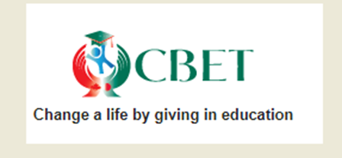
CBET Canadian Charity Reg No: 80114 6101 RR0001
Address: 365 Stoneway Drive, Nepean, Ontario, K2G 6G8, Canada.
Website: http://www.cbet.ca; Email: info@cbet.ca

2019 CBET Higher Education scholarship Application forms and rules for Bangladesh

[Application has to be written in English. Please complete application legibly and carefully. We will make the decision based on how nicely you write the application. We have left the application form half blank on purpose and just given you some hints for the application, so that you can use your talent and write a nice application. You need to submit the application via (through) email to info@cbet.ca and abumatin@hotmail.com.
There are two conditions for eligibility. First condition is that you received CBET 2018 Scholarship first and second instalment. The second condition is that you got admission into a Public University, (not Private University) or Government Medical College, (not Private Medical College) , Government engineering College, (not Private engineering College). If you satisfy these two conditions, you can submit this application for scholarship. Our decision is final whether your college or university or institution is accepted for CBET Higher Education Scholarship or not.
If you are selected, you will receive a one off payment of 7000.00 (seven thousand) taka in the first year and another one off payment of 8000.00 (eight thousand) taka in the second year if you are still studying at this institution or another institution to which you have been duly transferred. You will receive a crossed payee cheque from the organisation called Surovi, Dhaka.
For any question regarding this application or our scholarship, you can contact via email to info@cbet.ca and abumatin@hotmail.com. If you want to know more about CBET, please visit our website at http://www.cbet.ca.

To
CBET
365, Stoneway Drive,
Nepean, ON K2G 6G8
CANADA.

Subject: 2019 CBET Higher Education scholarship Application

The Greeting/The salutation:

Opening paragraph:

Information about you, for example, your name, current and permanent address, mobile no and email address.

Body of the application which will cover the following points:

1. State from which college and in which year, you received CBET 2018 scholarship first and second instalments:

2. Your HSC Examination result, grade and GPA:

3. Name and address of the institution where you are studying now:

4. How CBET Scholarship helped you to get admission into this institution:

Closing paragraph:

Yours Sincerely

Signature:

Your name:

Date:

Proofs which are needed with the application:

1. Copy of your HSC Mark sheet.

2. Copy of your student ID card if any from the current institution.

3. Additional evidence of the admission into this institution, for example, copy of admission fees payment receipt or copy of admission test result sheet with your name on it etc.

4. A letter from your former college confirming that your received CBET scholarship 2018 first and second instalments and also confirming the year when you received this CBET scholarship.

5. If possible, a letter from any teacher of your department (of your current institution) confirming that you are a student of this department.

